**Vasistha**

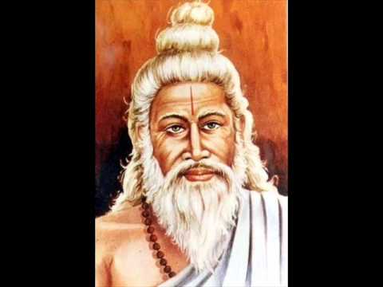

**Vashistha** is one of the [Saptarishis](https://en.wikipedia.org/wiki/Saptarishi) in the seventh, that is, the present [Manvantara](https://en.wikipedia.org/wiki/Manvantara). RigVeda mentions that Vashistha rishi as son of MitraVaruṇa and [Urvasi](https://en.wikipedia.org/wiki/Urvasi). It isalso mentioned that Vasishta was one of the Manasaputras of Brahma. To establish the rule of law Lord Brahma created seven sages who were shining with the brightness of the sun. They are Mareechi, Atri, Angirasa, Pulastya, Pulaha, Krathu and Vasishta. True to his name he was great, a person who shone with unparalled brightness, one who has conquered desire, anger, miserliness, jealously and pride. “Vashishta had the belief that the divine and individual efforts were very necessary for achieving anything in this world. According to him, the habit of laziness is actually a disease that is responsible to bring unhappiness in a man’s life.”

His work and composition were as thus: Yogavashishta Maharamayana, Vashishta Dharmasutra (Vashishta Smriti), Vashishta Sanhita which talks about astrology, Vashishta Purana, Vashishta Saddhakalp, Vashishta Shiksha, Vashishta Tantra etc. Another treatise attributed by him is "Vashistha Samhita"—a book on Vedic system of electional astrology.

As a Brahma Rishi he was very involved in the welfare of human beings. His hermitage was home to a lot of learned men. Many of the sages chose to build their hermitage in or around the hermitage of Vasishta. The hermitage is said to have been plush in greenery and it accommodated many animals too. “He was the preceptor of great men like Sri Rama and Harischandra. He was a great saint who humbled insolent men.” All the activities of the ashram were looked after and managed entirely by Arundhathi, the wife of Vasishta and she was a great tapaswini.

**Contributions of sage Vasistha**

Vashishtha is the author of the seventh book of the [*Rigveda*](https://en.wikipedia.org/wiki/Rigveda), one of its "family books" and among the oldest layer of hymns in the Vedic scriptures of Hinduism. The hymns composed by Vashishtha are dedicated to [Agni](https://en.wikipedia.org/wiki/Agni), [Indra](https://en.wikipedia.org/wiki/Indra) and other gods, but according to RN Dandekar, in a book edited by Michael Witzel, these hymns are particularly significant for four Indravarunau hymns. These have an embedded message of transcending "all thoughts of [bigotry](https://en.wikipedia.org/wiki/Bigotry)", suggesting a realistic approach of mutual "coordination and harmony" between two rival religious ideas by abandoning disputed ideas from each and finding the complementary spiritual core in both.These hymns declare two gods, [Indra](https://en.wikipedia.org/wiki/Indra) and [Varuna](https://en.wikipedia.org/wiki/Varuna), as equally great. In another hymn, particularly the Rigvedic verse 7.83.9, Vashishtha teaches that the Vedic gods Indra and Varuna are complementary and equally important because one vanquishes the evil by the defeat of enemies in battles, while other sustains the good during peace through socio-ethical laws. The seventh mandala of the *Rigveda* by Vashishtha is a metaphorical treatise. Vashishtha reappears as a character in Hindu texts, through its history, that explore conciliation between conflicting or opposing ideologies.

According to Ellison Findly – a professor of Religion, Vashishtha hymns in the *Rigveda* are among the most intriguing in many ways and influential. Vashishtha emphasizes means to be as important as ends during one's life, encouraging truthfulness, devotion, optimism, family life, sharing one's prosperity with other members of society, among other cultural values.

Vasishtha is a revered sage in the Hindu traditions, and like other revered sages, numerous treatises composed in ancient and medieval era are reverentially named after him.[[31]](https://en.wikipedia.org/wiki/Vasishtha#cite_note-FOOTNOTEOlivelle1999xxvi-33) Some treatises named after him or attributed to him include:

* The *Vashishtha samhita* is a medieval era [Yoga](https://en.wikipedia.org/wiki/Yoga) text.There is an [Agama](https://en.wikipedia.org/wiki/Agama_(Hinduism)) as well with the same title.
* The *Vashishtha [dharmasutra](https://en.wikipedia.org/wiki/Dharmasutra" \o "Dharmasutra)*, an ancient text, and one of the few [Dharma](https://en.wikipedia.org/wiki/Dharma)-related treatises which has survived into the modern era. This Dharmasūtra (300–100 BCE) forms an independent text and other parts of the Kalpasūtra, that is Shrauta- and Grihya-sutras are missing. It contains 1,038 sutras.
* The [*Yoga Vashishtha*](https://en.wikipedia.org/wiki/Yoga_Vasistha) is a syncretic medieval era text that presents [Vedanta](https://en.wikipedia.org/wiki/Vedanta) and [Yoga](https://en.wikipedia.org/wiki/Yoga) philosophies. It is written in the form of a dialogue between Vashishtha and prince Rama of [*Ramayana*](https://en.wikipedia.org/wiki/Ramayana) fame, about the nature of life, human suffering, choices as the nature of life, free will, human creative power and spiritual liberation. Yoga Vashishtha teachings are structured as stories and fables, with a philosophical foundation similar to those found in [Advaita Vedanta](https://en.wikipedia.org/wiki/Advaita_Vedanta). The text is also notable for its discussion of [Yoga](https://en.wikipedia.org/wiki/Yoga). According to Christopher Chapple – a professor of Indic studies specializing in Yoga and Indian religions, the *Yoga Vashishtha* philosophy can be summarized as, "Human effort can be used for self-betterment and that there is no such thing as an external fate imposed by the gods".
* The [*Agni Purana*](https://en.wikipedia.org/wiki/Agni_Purana) is attributed to Vashishtha.
* The [*Vishnu Purana*](https://en.wikipedia.org/wiki/Vishnu_Purana) is attributed to Vashishtha along with Rishi Pulatsya. He has also contributed to many Vedic hymns and is seen as the arranger of [Vedas](https://en.wikipedia.org/wiki/Vedas) during [*Dvapara Yuga*](https://en.wikipedia.org/wiki/Dvapara_Yuga).

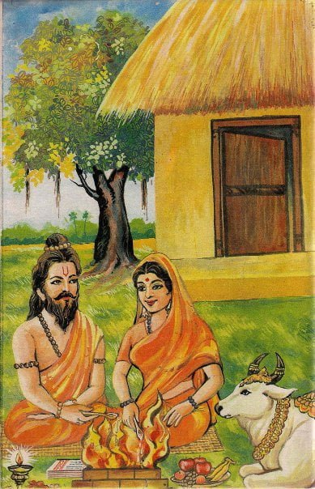**Stories featuring Vasistha**

Vasishta had his hermitage on the banks of the river Saraswati. Arundhati spent all her time in the service of her husband. He had with him thousand of disciples and taught them the Vedas. There was an atmosphere of peace in the hermitage. The plants and trees were full of flowers and fruits. A variety of birds sang and flew about in the hermitage. Herds of deer and cows lived there. There was a regular performance of several holy sacrifices for the good of the world. Several hundreds of visitors used to come to the hermitage to meet Vasishta.

He was a man of peace. He had conquered desire and anger. His Ashram needed great quantities of milk, curds, and ghee for the feeding of thousands of his disciples, guests, and performance of sacrifices regularly. Devendra had gifted to Vasishta a divine cow, having admired his generosity and performance of sacrifices. The cow was called Nandini.

She was the daughter of Kamadhenu. Since it was a divine cow it had extraordinary powers. The Ashram got plenty of milk and ghee from this cow. Since it had moonlike patches all over the body, it was also called ‘Shabala.’ The word means many-colored.

### The Arrival of Vishwamitra

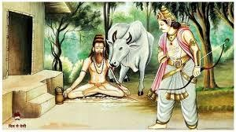

In those days, there was this King named as **Kaushika** (Vishwamitra). Once while returning from hunting, Vishvamitra was passing by Vasishtha’s ashram. He thought of taking some rest with all his army at his back. Vishwamitra saluted Vasishta with proper respect and diligence. Vasishta was also very glad to meet Vishwamitra. He also gratified the king and his army with fruits and other delicacies. After this, the king wanted to leave as he couldn’t stay at his ashram because of the large army he had with him, and the food won’t suffice for all of them taken together, and since the people in the ashram had to be fed too. But Vasishtha didn’t allow the king to leave the empty stomach and supplied him with a sufficient amount of food and supper. The king was very much delighted at this. He was very much influenced and inspired by the ethics possessed by Vasishtha and the values he spread in the service of others. He suddenly turned into a greedy man and demanded the cow to take with him to his kingdom from Vasistha. But this demand was refused by Vasistha as this was a gift from the Devaraj, Indra. This led to a heated argument between the two and finally, this turned into a big fight, in which Vasistha won because Nandini had magical powers through which she was able to defeat the entire army of Vishwamitra.

**Role in Ramayana**

Since Vashishta was immortal he lived through a lot of episodes in his life. He was the royal priest to Dasaratha, father of Rama. Dasaratha did not have children for a long time and as per the advice of Sage Vasishta the king decided to conduct Aswamedha Yaga under the supervision of Sage Rishishringa at the banks of River Sarayu. Along with the Aswamedha, Rajasuya yoga was also performed. Along with the Aswamedha, Rajasuya yoga was also performed. As a result 4 sons were born to the three queens of king Dashratha. Vasishta namedthem Rama, Lakshamana, Bharatha and Shathrugha.

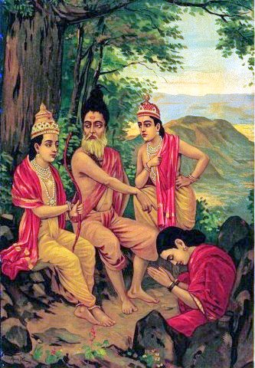Vishwamitra once came to the palace requesting Dasaratha to send Rama with him to the forest to protect his Yaga from the Asuras who were disturbing him and not letting him finish the yaga. Dasaratha did not want to send Rama as he was still very young, but on Vasishta’s advice complied to sage Vishwamitra’s request.

Later on, after Rama returned after killing Ravana Vaishta conducted his coronation ceremony. Sage Vasishta took great care and interest in the welfare of the royal family of ayodhya and the smoothrunning of the administration of the kingdom of Ayodhaya.

**Curse upon the eight vasu**

The Vasus are the attendant deities of Indra. Once they voisited the ashrama when Vashista was away. One of the Vasu’s Prabhasa/Dyaus/Dhava’s wife took a liking to Nandini the divine cow and wanted to possess it. She had heard that milk of that cow was equal to nectar and the one who drank would become immortal, and thus her desire to possess Nandini became an obsessioin. She wanted to give the milk of this cow to her friend Jeethavathi and so forced her husband to grab it for her. Dyaus was forced to comply to the wishes of his wife. Nandini was thus taken away by force and the rest of the 7 vasus looked on.

On his return Vasishta realised that Nandini was gone and he saw what had happened and it made him and very and he cursed the 8 Vasus to be born as mortals. The Vasus went to the age to seek his forgiveness and seek freedom from the curse incurred. Vasishta explained that once the curse is been uttered it would take its course, but he promised that the 7 Vasus who were onlookers to the deed would be freed of the curse after few moments on earth but Dyaus would live a full life, but as a noble soul.

**Temples of sage Vasistha**

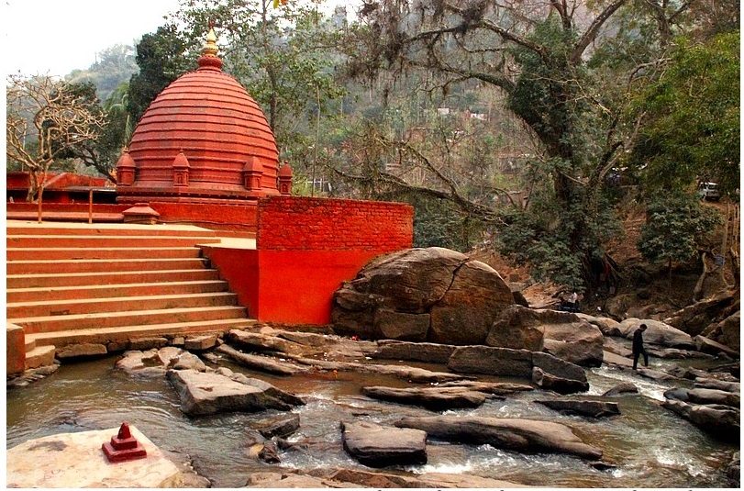

There is an Ashram dedicated to Vashishtha in [Guwahati](https://en.wikipedia.org/wiki/Guwahati), [India](https://en.wikipedia.org/wiki/India). This Ashram is situated close to [Assam](https://en.wikipedia.org/wiki/Assam)-[Meghalaya](https://en.wikipedia.org/wiki/Meghalaya) border to the south of [Guwahati](https://en.wikipedia.org/wiki/Guwahati) city and is a major tourist attraction of Guwahati. Vashishtha's Temple is situated in [Vashisht](https://en.wikipedia.org/wiki/Vashisht_(Village)) village, Himachal Pradesh. Vashishtha Cave, a cave on the banks of [Ganges](https://en.wikipedia.org/wiki/Ganges) at Shivpuri, 18 km from [Rishikesh](https://en.wikipedia.org/wiki/Rishikesh) is also locally believed to be his winter abode and houses a Shiva temple, also nearby is Arundhati Cave.

Guru Vashishtha is also the primary deity at [Arattupuzha Temple](https://en.wikipedia.org/wiki/Arattupuzha_Temple" \o "Arattupuzha Temple) known as Arattupuzha Sree Dharmasastha in [Arattupuzha](https://en.wikipedia.org/wiki/Arattupuzha" \o "Arattupuzha) village in [Thrissur](https://en.wikipedia.org/wiki/Thrissur) district of [Kerala](https://en.wikipedia.org/wiki/Kerala). The famous [Arattupuzha Pooram](https://en.wikipedia.org/wiki/Arattupuzha_Pooram" \o "Arattupuzha Pooram) is a yearly celebration where Sri Rama comes from the [Thriprayar Temple](https://en.wikipedia.org/wiki/Thriprayar_Temple" \o "Thriprayar Temple) to pay obeisance to his Guru at Arattupuzha temple.